**Kodu with Touch**

Last Updated

# High Level Player Experience

Kodu via a touch screen interface makes it easier than ever to create!

**Feature Priority:**

*Key Feature*: A major feature. It interconnects with multiple core features and is a major part of the player experience.

# Design Details

**Goals:**

* To enable a creator to create and edit in Kodu via a touch based interface able to gain their intended results with effortless precision.

**Design Details:**

**Breakdown**:

* Introduction
* Touch Gestures
* Camera controls
* Home Menu
* Play Game
* Tool Menu
* Radial Selector
* Settings Lists
* Object Mode
* Koding

**Introduction**

This document outlines the use of touch controls in Kodu for Win8. The goal is to enrich the Kodu experience by using simple and intuitive controls while maintaining all the current features found in the program. Much of the gestures and UI mechanics are based on Windows 8’s Metro UI.

**Touch Gestures**

**Core Gestures**

The following are the standard touch interactions from Microsoft’s Metro style app development. These interactions are referenced in the rest of the document.

|  |  |  |  |
| --- | --- | --- | --- |
| **Tap** | **Press and Hold** | **Drag** | **Swipe/Cross-slide** |
|  |  |  |  |
| One finger is placed down briefly to set focus, and then lifted up without sliding. | One finger is placed down without moving. A short duration before action is executed. | One or more fingers are placed on a moveable UI element and move in the same direction. The fingers are not lifted until the action is complete. | One finger is placed on an object and dragged at a right angle to the activation edge. direction. E.g. drag from the bottom of the screen upwards. |
| **Pan** | **Pinch & Spread** | **Rotate** |  |
|  |  | 1323302498_redo.pngfinger_small.png |  |
| One or more fingers are placed on a scrollable UI surface and move together across the surface. | Two or more fingers are moved closer together (pinch) or farther apart (spread). | Two or more fingers are moved in a clockwise or counter-clockwise arc. |  |

**General Gestures**

|  |  |  |
| --- | --- | --- |
| **Feature** | **Gesture** | **Action** |
| Select option | Tap | Tap on an icon to select an option (ex. Turn on/off option) |
| Select object | Tap | Note objects have a larger ‘touchable’ area than when using mouse to aid in object selection. This scales with distance to object; closer=smaller. |
| Tooltip | Press and Hold | Press and hold on an icon to display a tooltip (ex. Move camera). Removing the finger does not select initiate the tool. |
| Slide menu | Drag | Drag a finger left/right to slide the menu left/right |
| Close/cancel | Slide from edge | Slide finger from the top/bottom edge down/up. |

**Camera Controls**

|  |  |  |
| --- | --- | --- |
| **Feature** | **Gesture** | **Action** |
| Zoom | Pinch & Spread | Pinch 🡪 zoom in  Spread 🡪 zoom out  Zoom focus is the center of the two points being pinched/spread apart at the beginning of the action. It does not move during the gesture. |
| Pan | Pan | Slide screen in the direction of slide using one finger.  User taps to ‘grab’ the world and uses movement to drag the world, visually panning across it. |
| Rotate | Rotate | Rotate world screen in the direction of pan using **two adjacent fingers.** Like a volume control knob, rotating. This has the result of rotating the world around the vertical Z axis at a point that has its origin in the center of the screen. |
| Tilt | Two Finger Pan | Tilt (or ‘orbit’) camera viewpoint upwards or downwards, retaining the same distance from the center of the screen. |

As an extension to this functionality, it would be useful to the User to be able to Zoom and Rotate at different speeds depending on the number of fingers they are using.

The touch version of Kodu has an invisible border around the visible space. Should the User select an asset or attempt to place an asset inside of this visual border, the camera will shift to include the asset inside of the border. E.g.:

**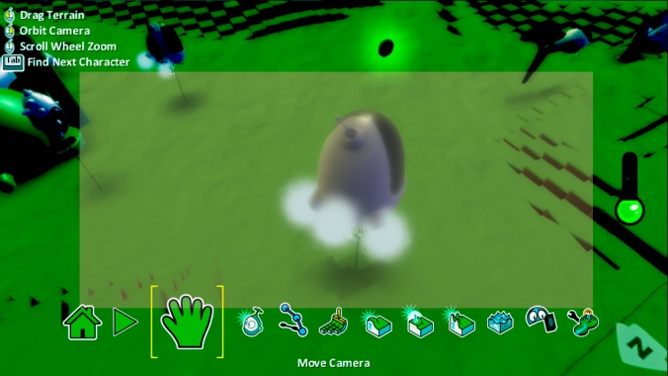**

(image from PC Kodu)

**Home Menu**

The home menu is access from the tool menu by tapping the house icon.

## Play Game

In Play Game mode (either through Home Menu or through Edit > Play), the gestures programmed in the “kode” take precedence over system gestures.

The layout remains the same except that the usual icon ‘Edit’ icon that appears on the screen is placed in the corner and requires a tap to exit to Edit mode.

Just as in standard Kodu, pressing Play from the edit menu will restart the level. For information relating to linked levels, see the linked levels design document:

SGI - Kodu - Linked Levels.docx

**Tool Menu**

The Tool menu is similar to the current layout used in Kodu Mouse version.

The available tools are:

1. Home
2. Play Game
3. Object Tool
4. Path Tool
5. Add & Paint Terrain
6. Camera \*
7. Raise/Lower Terrain
8. Flatten Terrain
9. Roughen Terrain
10. Water tool
11. Delete tool
12. Change World Settings

\*Exact position in list TBC based on user testing during terrain mode development.

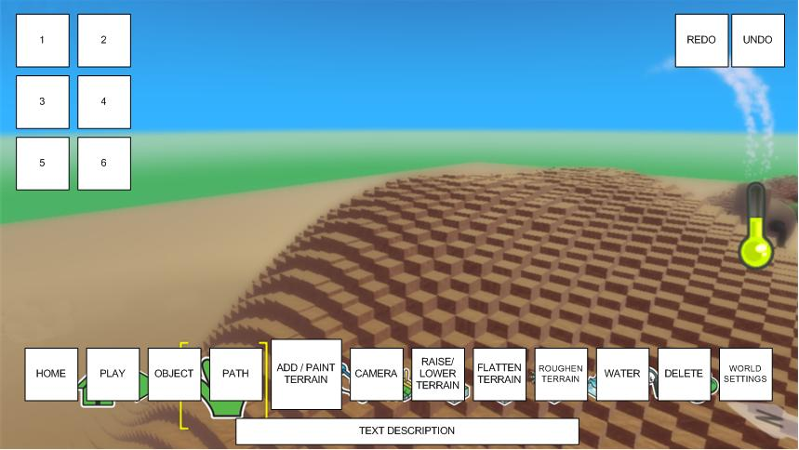

**Radial Selector**

Touch controls will be added to the Radial selector.

Appearance:

* Object Edit Mode:
  + Double tap on empty space brings up the add object Radial selector.
  + Press and Hold on empty space brings up the generic world/add Radial selector
  + Single tap on pre-selected object
* Koding Mode: Tap on an existing tile to change it or a + sign to add a new tile.

Removal:

* To exit the Radial selector the player taps on empty space. Note there is a small extension of ‘dead space’ around the Radial selector to ensure a User doesn’t exit via miss-tap.

Interaction:

* Tap a slice to select it. If there are sub options, an additional radial appears over the parent slice.
* Users can tap a slice to select it
* Users can tap the parent slice or any other visible slice from the parent selector to close the sub-radial or tap anywhere not on the radial(s) to close all of them.

|  |  |
| --- | --- |
|  |  |

|  |  |
| --- | --- |
| **Gesture** | **Action** |
| Tap | Tap slice to select |
| Tap | Tap anywhere not on the radial to close all |
| Press and Hold | Show tooltip. When User releases slice, the selection is not placed; the User has to again tap their choice. |

**Settings lists**

Touch controls will be added to the settings menus to make them easy navigate and use.

The black help button shown in the image below will be updated to a simple tap to access.

They retain the twisted column appearance:

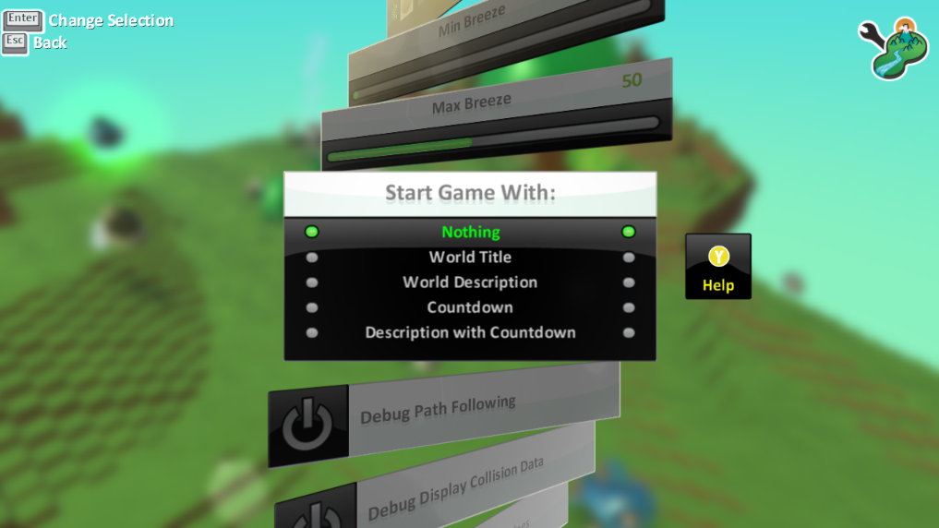

(image from PC Kodu)

|  |  |
| --- | --- |
| **Gesture** | **Action** |
| Tap on empty space | Exit settings menu back to Object Edit mode. EXCLUDING the gaps between options, these are dead space. |
| Tap on toggle setting | Toggle setting on/off. E.g. ‘Debug Path Following’ in image above |
| Tap on multiple choice | Cycle through choices. E.g. ‘Start Game With:’ in image above |
| Tap on Help button | Brings up help dialogue |
| Press and Hold | Show tooltip. When User releases slice, the selection is not ‘engaged’; the User has to again tap their choice. |
| Swipe on range option | Alter setting of a range value by adjusting the visual bar by swiping. E.g. ‘Max Breeze’ in image above, and sky settings. |
| Pan up/down over settings – excluding highlighted setting in center of screen. | Moves up/down the settings listing. |

**Object Mode**

There are two primary actions with the Object tool, placing a new object or selecting an existing object. With either action, a visual cue will appear to confirm the touch action (ex. Object is highlighted or marker appears on the ground.)

Object mode is where the User will spend a good portion of time, so interface is critical here. For this reason, a single tap on empty space performs no action other than to deselect an object. Experience/history shows this to be best practice.

To place a new object the User double taps on an empty spot on the ground. The radial selector will appear fills with the available objects. Users then tap an object slice and the object will appear on the ground at the markers position. Available options:

**Contextual Radial 1 – Add Objects**

In Edit mode, when the User double taps empty space (i.e. no object beneath touch point) a context Radial selector appears. This offers a list of contextual options, #1 is at the top and continues down the list in clockwise appearance order.

1. Kodu
2. Rover
3. Apple
4. Items
   1. Objects 1 (characters)
   2. Objects 2 (characters)
   3. Objects 3 (buildings)
   4. Things (other:
5. Tree
6. Paths
7. Paste

**Contextual Radial 2 – Object Options**

In Edit mode, when the User taps a selected object a context Radial selector appears. This offers a list of contextual options, #1 is at the top and continues down the list in clockwise appearance order.

1. Program
2. Settings
3. Cut
4. Clone
5. Change Size
6. Pick up
7. Change Height
8. Change color

**Contextual Radial 3**

In Edit mode, when the User taps and holds an empty space (i.e. no object beneath touch point) a context Radial selector appears. This offers a list of contextual options, #1 is at the top and continues down the list in clockwise appearance order.

1. Paste
2. World Settings
3. Add Object

|  |  |
| --- | --- |
| **Gesture** | **Action** |
| Tap | No Action / deselect object |
| Tap on object | Select |
| Tap with object selected | Open contextual Radial 2 |
| Press and Hold | Show tooltip. When User releases slice, the selection is not placed; the User has to again tap their choice. |
| Press and drag on object | Object is dragged to the point where the Users finger is touching |
| Pinch/Spread with object selected | Resize object \* |
| Rotate with object selected | Object is rotated\* |
| Pan up/down | Raise /Lower object height |
| Tap and hold | Contextual Radial 3 |
| Double tap | Contextual Radial 1 |

* \* Sensitivity to be adjusted. Note: younger hands start with a smaller thumb to index finger distance.
* When Users are modifying an object, the yellow selection glow around that object changes to purple.
* Also see camera controls for full suite of gestures used in this mode.

**Path tool**

Adding paths is based off of the mouse Kodu interface.

1. The User selects a path tool from the edit menu and places it in world with a tap.
2. The placed path node is highlighted. The user taps it and a radial appears that includes, extend path, color, type, delete. (I.e. usual path options)
3. Selecting extend paths allows the User to place another node. This node is already connected to the initial, preceding node placed in step 1. Path functionality remains the same.

Alternatively:

1. The User selects a path node from the object radial selector and places it in world with a tap.
2. The User taps + holds the path node and a new node is created, attached to the initial node. User moves their fingertip to the desired point and releases it to place it. Moving to the edge of the screen causes the world to scroll.

**Koding**

The Koding menu will be familiar but with several tweaks. The major change is the use of the addition of the Page selector.

[Note: in the image below only 8 pages are shown, however we will be showing all 12 pages]

*Reflex*

**WHEN**

**+**

**DO**

**+**

*Page Selector*

**+**

**WHEN**

**+**

**DO**

**WHEN**

**+**

**DO**

**+**

**+**

**DO**

**+**

**WHEN**

Page 7

Page 6

Page 5

Page 4

Page 3

Page 2

Page 1

Page 8

**Reflex**

The reflex (lines of code) appears and function almost the same as before but with added touch control.

New Radial Selector appears when the User taps on a line number.

* Delete
* Cut
* Paste
* Add line

|  |  |
| --- | --- |
| **Gesture** | **Action** |
| Tap on line number | Show Radial selector: Delete, Cut, Paste, Add line |
| Drag + line number | Detach line to move it up and down the list to change the order. Players can also slide the line into a different page by sliding it to the page number where the reflex will then update and the line can be dropped anywhere on the list. |
| Tap + “When” filter | Show existing filters on Radial selector (ex. See, hear, bump, etc.) |
| Tap + “Do” modifiers | Show existing modifiers Radial selector (ex. Move, turn, eat, etc.) |
| Pan left/right/up/down | Slides the entire Reflex in the drag direction. |
| Tap on empty space | Exit Kode mode. |
| Slide | Band box select multiple lines |

**Page Selector**New to Kodu is the Page selector. This allows players to quickly select a page to change to and be used to drag and drop reflex kode lines

|  |  |
| --- | --- |
| **Gesture** | **Action** |
| Tap on page number | Selects the tapped page |
| Pan left/right | Slides the entire Page selector left and right |

**Control tiles**

The following are the gestures that can be assigned for gameplay:

|  |  |
| --- | --- |
| **Control** | **Action** |
| Tap anywhere/target | Tap anywhere on the screen or on set target |
| Swipe left/right/up/down/any/strength | Swipe in a particular direction or any direction. May include strength of swipe (ex. Strong and weak) |
| Slide left/right/up/down/any/object | Slide in a particular direction or any direction. May or may not need an object target |
| Rotate left/right/any | Rotate in a particular direction or any direction |
| Buttons | Press On screen buttons |
|  |  |